

- Category : Platform
- Target : 12+
- Players : 1
- Languages : Eng
- Available : August 2004

Honour to the sword of ninja!

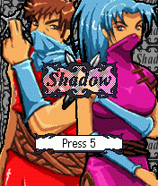
Scenario
There is a pact of honour between Musashi and his sister Kaede: before the rising of a new dawn the evil Veril will have to be defeated. The future of the human race now depends on the strength and tenacity of these two valorous ninja. Meanwhile, Veril is preparing to summon the demon Murasaki, whose power is only matched by his ferocity.

But that’s not all: platoons of evil soldiers, devoted to the glory of Murasaki, have been trained for one mission: the annihilation of Musashi and Kaede, and they will certainly not surrender! This time, there is nothing left to lose. Between slavery and death there is but one solution: fight to the end.

Game Features
Shadow is a platform-game with multi-directional scrolling characterized by a superior graphic quality and hours of enjoyment.
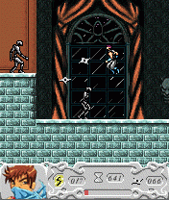
The game’s dynamics are gripping: to reach the final clash with you will have to complete the 6 stages of the first phase up to the third difficulty level. Only after having tackled Veril with both ninja, will you be able to access the final duel.

Both Musashi and Kaede possess personal weapons with individual characteristics: choose your own ninja, discover the secrets hidden through the various environments of the game and find the way out. Of course, the way out only leads to the final, most dangerous reckoning!

Strong Points
- Multi-directional scrolling for limitless adventures!
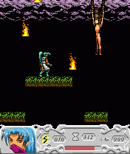
- Environments extended by fluid and accurate graphics.
- Two distinct personages with characteristic, personal weapons.
- Original and captivating narrative structure.
C O M P A T I B I L I T Y T A B L E
Nokia | 3100 | 3200 | 3300 | Motorola | T720 | V300 | V303
Nokia | 3510i | 3520 | 3530 | Motorola | V500 | V525 | V600
Nokia | 3560 | 3595 | 3650 | BlackBerry | 7210 | 7230 | 7280
Nokia | 3660 | 5100 | 5140 | BlackBerry | 7510 | 7290
Nokia | 6100 | 6200 | 6220 | Samsung | D500 | E710 | P400
Nokia | 6230 | 6600 | 6610 | Sharp | GX10 | GX20 | GX22
Nokia | 6800 | 6810 | 6820 | Sharp | GX30 | GX32
Nokia | 7200 | 7210 | 7250 | Siemens | A60 | C60 | C65
Nokia | 7250i | 6610i | 7650 | Siemens | CX65 | M55 | MC60
Nokia | 8910i | N-Gage | 3105 | Siemens | S55 | SL55 | SX1
Nokia | 3108 | 3120 | 3125 | Sony  Ericsson | K700 | P800 | P900
Nokia | 3205 | 3220 | 6108 | Sony  Ericsson | Z600
 | 6225 | 6585 | 6630

